Name of Student : Raghav Mahesh Sarda PRN: 25070122235
Subject: Programming with Java Semester: III
ASSIGNMENT No : 17 Year: AY 2026-27
TITLE : Swing and Applets

Problem Statement
Write a Java program to demonstrate the use of Swing and Applets.

Learning Objectives
To develop graphical user interfaces using Swing components and Applets.

Program:
UserRegistration.java
// Assignment 17 - Exercise 1: Swing GUI Window Application
import javax.swing.*; // For GUI Components
import java.awt.*; // For Layout
public class UserRegistration
{
public static void main(String args[]) // Main Method
{
JFrame frame = new JFrame("Student Registration Form"); // Creating top-level window frame
frame.setSize(400, 300); // Setting frame dimensions
frame.setLayout(new GridLayout(4, 2, 10, 10)); // Setting grid layout with spacing
frame.setDefaultCloseOperation(JFrame.EXIT_ON_CLOSE); // Closing operation

// Name
JLabel lblName = new JLabel("Enter Name: "); // Label
JTextField txtName = new JTextField(); // Textfield for input

// Roll No
JLabel lblRoll = new JLabel("Enter Roll No: "); // Label
JTextField txtRoll = new JTextField(); // Textfield for input

// Branch
JLabel lblBranch = new JLabel("Enter Branch: "); // Label
JTextField txtBranch = new JTextField(); // Textfield for input

// Buttons
JButton btnSubmit = new JButton("Submit"); // Submit button
JButton btnReset = new JButton("Clear"); // Clear button

frame.add(lblName); // Adding name label to frame
frame.add(txtName); // Adding name textfield to frame
frame.add(lblRoll); // Adding roll label to frame
frame.add(txtRoll); // Adding roll textfield to frame
frame.add(lblBranch); // Adding branch label to frame
frame.add(txtBranch); // Adding branch textfield to frame
frame.add(btnSubmit); // Adding submit button to frame
frame.add(btnReset); // Adding reset button to frame

frame.setVisible(true); // Displaying frame window
}
}

AppletDemo.java
// Assignment 17 - Exercise 2: Basic Java Applet
// HTML Run Code: <applet code="AppletDemo.class" width="350" height="200"></applet>
// Executing via Swing as Applet support has been deprecated.
import java.applet.Applet; // Applet package
import java.awt.*; // AWT graphics and fonts
import javax.swing.JFrame; // Swing JFrame container

public class AppletDemo extends Applet // Applet base class
{
public void init() // Applet initialization lifecycle method
{
setBackground(Color.LIGHT_GRAY); // Setting background color
}
public void paint(Graphics g) // Paint lifecycle method for rendering graphics
{
g.setColor(Color.BLUE); // Drawing color
g.setFont(new Font("Arial", Font.BOLD, 16)); // Text font
g.drawString("Welcome to Java Applet Programming!", 30, 60);

g.setColor(Color.RED); // Drawing color
g.drawRect(30, 80, 280, 50); // Rectangle outline
g.drawString("Symbiosis Institute of Technology", 45, 110);
}

public static void main(String args[]) // Main Method
{
JFrame frame = new JFrame("Applet Viewer"); // Creating top-level window frame
AppletDemo applet = new AppletDemo(); // Creating instance of AppletDemo

applet.init(); // Calling applet lifecycle initialization
applet.start(); // Starting applet execution

frame.add(applet); // Adding applet to frame container
frame.setSize(365, 235); // Setting frame dimensions matching applet bounds
frame.setDefaultCloseOperation(JFrame.EXIT_ON_CLOSE); // Closing operation
frame.setLocationRelativeTo(null); // Centering frame on screen
frame.setVisible(true); // Displaying frame window
}
}

Output:
UserRegistration.java
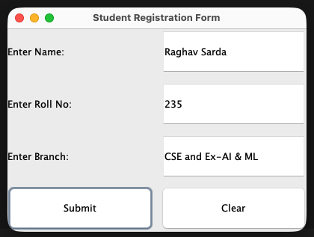
AppletDemo.java
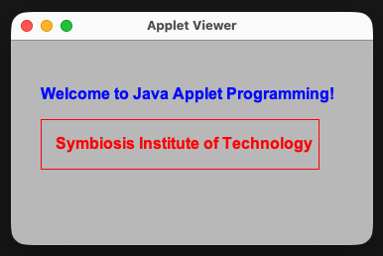

Conclusion:
In this assignment, the concepts of graphical user interface design using Java Swing components and Applets were successfully implemented. Swing provided lightweight, platform-independent GUI elements like frames, labels, and text fields for interactive window applications, while the Applet demonstration (using Swing package, as Applet has been deprecated) illustrated direct graphical rendering within embedded environments.

